Google Business Profile
SOP | Manipal Hospitals
Details Required from Regional Teams – GBP Creation
1.New Account Creation
- A GBP profile is created only after the doctor is officially onboarded and the ticket is raised on the dashboard.
- Share a valid phone number for verification — the coordinator's or the doctor's attendee's number works. Google sends an OTP to this number; once verified, the profile is optimized within 3–5 days.
Existing GMB Account (Doctor)
- Linked to a private clinic/other address: A new profile is created under the Manipal location.
- Linked to the doctor's previous employer: Ask the doctor to request their previous manager to transfer ownership/access to Manipal Hospitals.
- Already linked to Manipal Hospitals: Ask the doctor to add the team as owner and then transfer the primary ownership to the corpgmb.admin@manipalhospitals.com email ID after 7 days.
1. Business Name Guideline
Information Checklist
Regional teams should have the following ready before raising a creation request:
Category | What to Provide
Business Identity | Business name (Hospital/Doctor name)
Location | Complete address with PIN/ZIP code, incl. door/floor no.
Contact | Contact number and official website URL
Categories | Primary and secondary business categories
Hours & Location | Working hours; Google Maps latitude & longitude
Description | Business description with relevant keywords
Services/Products | List of services and products, with descriptions
Booking | Appointment booking link
Attributes | Business attributes (e.g. wheelchair access, parking)
Media | Cover photo, exterior photos, interior photos, patient-treatment success photos
Regional Team Responsibilities
- Ensure all information shared is accurate and complete.
Share the required documents and media assets up front.
- Confirm business name and address before profile creation.
- Flag any special or business-specific requirements to the GMB team.
- Review profile details before final submission.
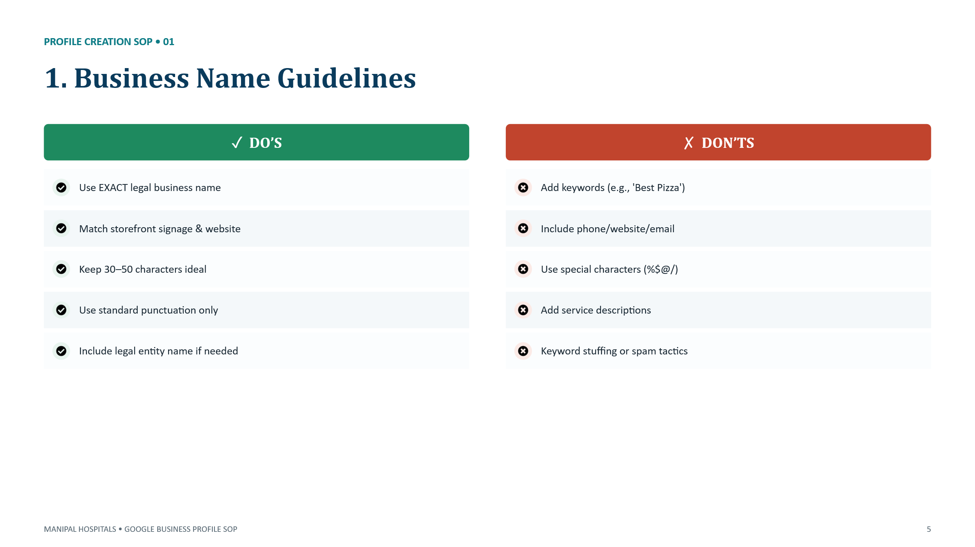

Google Guideline: https://support.google.com/business/answer/3038177#zippy=%2Cname
2. Business Description
Write a clear and accurate description of your business, services, and unique value. Keep it within 750 characters, use natural language with relevant keywords, and avoid promotional content, keyword stuffing, contact details, links, or misleading information.
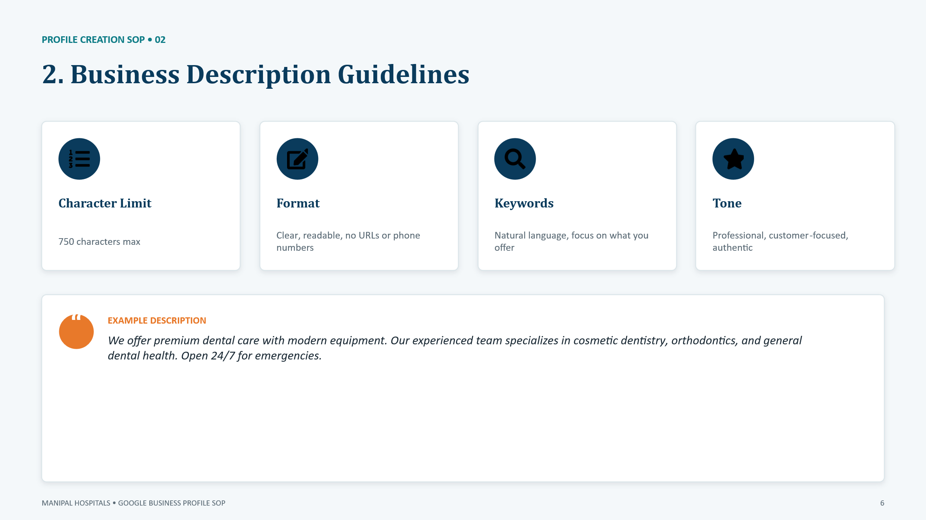
Google Guideline: https://support.google.com/business/answer/3038177#zippy=%2Cbusiness-description
3. Categories and Photos
Select the most accurate primary category that best represents the business. Add relevant secondary categories only if they match the actual services offered. Avoid selecting unrelated or excessive categories.
Upload high-quality, relevant photos that represent the business, including exterior, interior, products/services, team, and customer experience images. Keep photos updated and avoid stock images or misleading visuals.
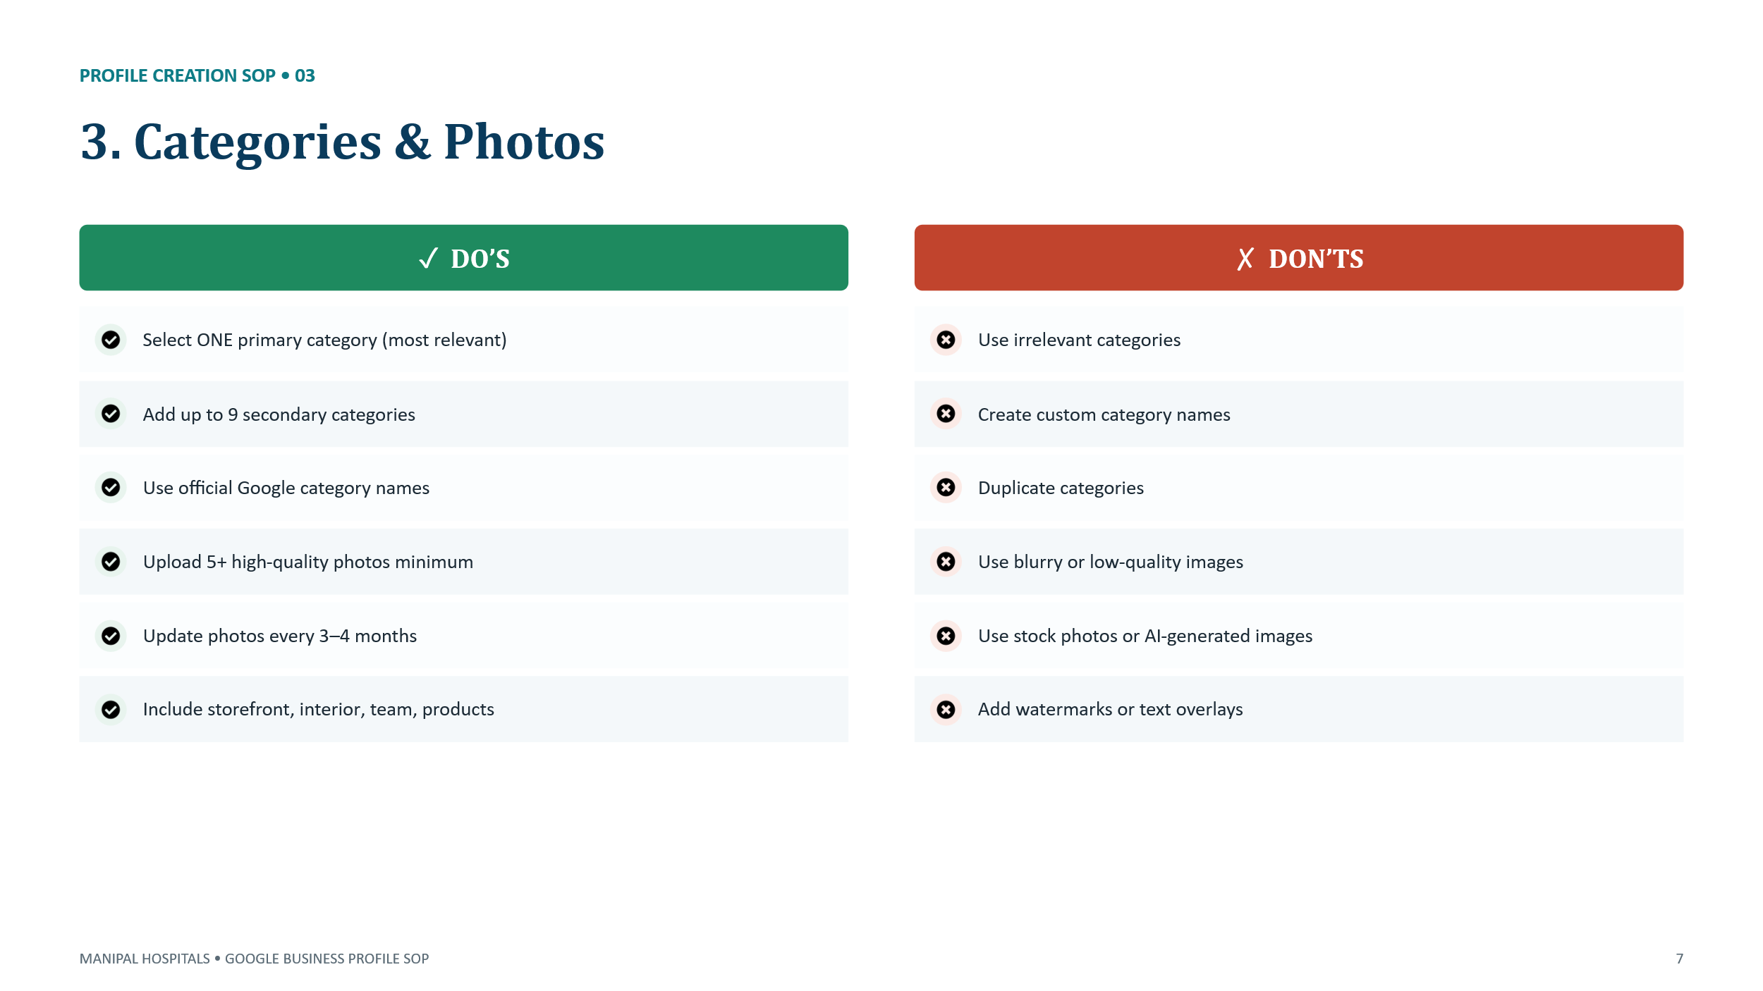
Google Guideline: https://support.google.com/business/answer/3038177#zippy=%2Ccategories
4. Verification methods
Complete verification using the methods provided by Google, such as phone, email, video verification, or postcard (if available). Ensure the business information is accurate and supporting documents are ready. Use official business details and avoid creating duplicate profiles to prevent suspension. 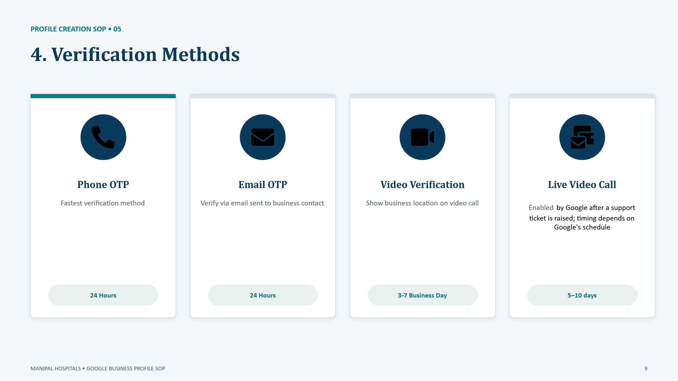
Google Guideline: https://support.google.com/business/answer/3038177
Reference guide for the business verification process.
Method | Turnaround | Notes
Text Message (OTP) | 24 hours | Fastest method – OTP sent to registered mobile number
Email (OTP) | 24 hours | OTP sent to registered email address
Video Recording | 3–7 business days | Submit a clear video of the exterior/signage; Google reviews and approves
Live Video Call | 24–48 hours | Enabled by Google after a support ticket is raised; timing depends on Google's schedule
Video Verification [Current Process]
- Multiplier Team will provide temporary Google Business Profile access to the Unit SPOC. [This step will change once the Google Workspace Email IDs are linked as primary owner/manager to all GBPs].
- Access will be shared only with the official @manipalhospitals.com email ID.
  - Personal email IDs (e.g., @gmail.com) will not be granted access.
- The Unit SPOC records and submits the live verification video through the Google Business Profile.
- The video should include:
  - Hospital Signboard
  - Main Entrance
  - Reception/Registration Desk
  - Doctor's Cabin
  - Doctor's Name Board
- Once verification is completed:
  - Multiplier validates the profile.
  - Temporary access provided to the Unit SPOC is removed (as per current process).
5. Profile Suspension Guidelines:
Follow Google Business Profile guidelines to avoid suspension. Ensure business information is accurate, avoid fake or duplicate listings, use the correct business category, maintain ownership details, and do not use prohibited content or misleading information. Review and fix policy violations before submitting a reinstatement request
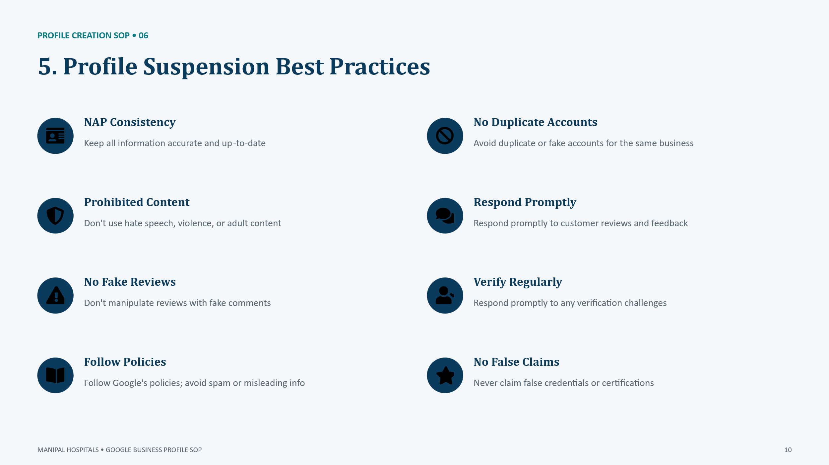
Google Guideline: https://support.google.com/business/answer/4569145?hl
6. Practitioner Profile Guidelines:
Create a separate practitioner profile only for eligible professionals who provide services directly to customers. Ensure the practitioner's name, category, and information are accurate. Avoid creating practitioner profiles for non-public-facing staff, duplicate profiles, or individuals who do not meet Google's eligibility guidelines.
Google Guideline: https://support.google.com/business/answer/3038177#zippy=%2Cname

